How Many Carrots?
Alexa Alexander

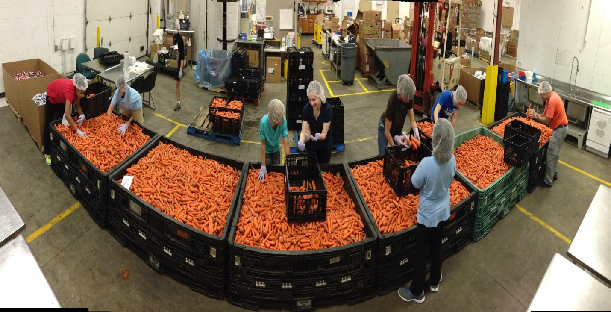
North Park Montessori Middle schoolers volunteered at Feeding America during 361.

PHILANTHROPY- Carrots are good for eye sight, right? Well, maybe sometimes. These 7th graders are at Feeding America for their day at 361. 361 is a philanthropy project that they do each month. Philanthropy is a generous way to give back towards others. Feeding America is a non-profit food bank that helps our community. But it was a little different then what they suspected.

They had to put thousands, upon thousands of pounds of carrots in oversized crates. The cold carrots managed to make the students hands numb, and made their vision a blurry orange. At the end of the day, the students put 7 tons (14,000 pounds) of carrots in crates. “I can never look at another carrot again” or “I am praying that we’ll not have carrots for dinner tonight” was all the students could say.

The carrots are going to Kids Food Basket and Gods Kitchen, other places they go for 361.
The adolescences enjoy it as much as the people who get it do. Philanthropy is a big part of their community, and we plan to keep it that way for a long, long time! Just minus the carrots…

