Barrels of Love
By: Elle Waldron
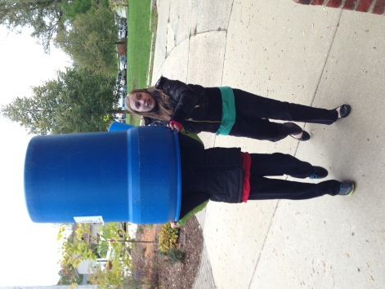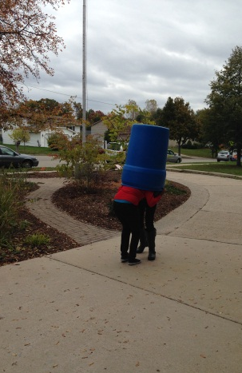
Cordell Frahm, Elle Waldron, Anna Kayner, Anna Kayner guides Cordell Nyleese Burns & Elle W.
& Nyleese Burns carry barrel up hill. Frahm inside. Get stuck in a barrel.

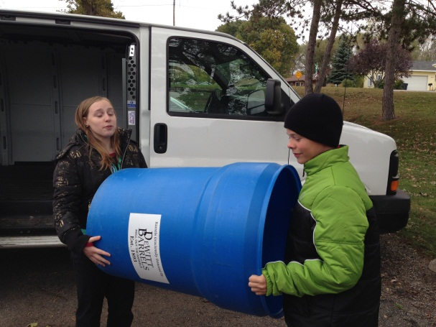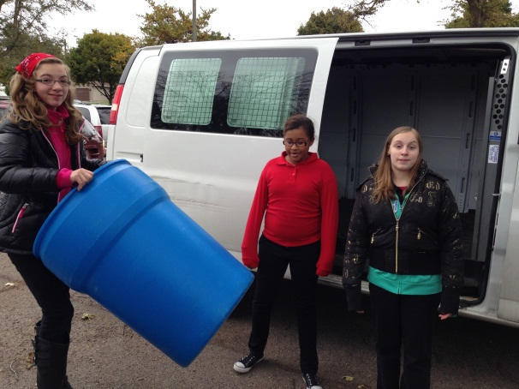
Anna Kayner & Cordell Frahm carry a barrel. Elle Waldron, Nyleese Burns, & Anna Kayner.

SERVICE LEARNING-To anyone walking by this may look like a few kids on a fall day playing a silly game; rolling blue barrels down the sidewalk, giggling softly.
But there is much more to this picture then what it looks. These barrels will be filled with love. It is the physical example of our school making our community a better place by helping to eliminate hunger and encouraging future generations to do the same.
These Middle School students are creating amazing opportunities for themselves and their peers.
The bulky blue barrels (above) are property of Gods Kitchen a local soup kitchen, food pantry, and baby pantry. Students have coordinated with Jeff Hoyh, our contact at God’s Kitchen, to get the barrels transported to our school. The barrels will be used collect items like canned and boxed food for God’s Kitchen’s food pantry. They will also be used to collect baby items, which help struggling mothers and families in Grand Rapids.
These simple blue barrels are really an open door, a gateway. They are a small way to help our North Park community get involved and share our big hearts with others. By collecting items for God’s Kitchen we are teaching our students the challenges and hardships of life, but we’re also teaching them how to overcome them and how help others do the same. “We can’t fully understand what these people we’re helping are going through, but we can help them get through it. When I see the ways it helps so many types of people, how a little thing like a blanket for their baby can make life so much easier, it makes me want to do even more for my community. Even if it only helps one person, that’s one more person than before, and maybe that will encourage that person to help someone else in need.” Says Elle Waldron. North Park may be a small school but they sure do have a big heart!

